Mockito Hands-On Exercises – Module 4 – Hands-on-Exercise
Name: Monika M
Mail id: monikamohann@gmail.com

Exercise 1: Mocking and Stubbing Scenario:
pom.xml code:
<project xmlns="http://maven.apache.org/POM/4.0.0"
xmlns:xsi="http://www.w3.org/2001/XMLSchema-instance"
xsi:schemaLocation="http://maven.apache.org/POM/4.0.0
https://maven.apache.org/xsd/maven-4.0.0.xsd">

<modelVersion>4.0.0</modelVersion>

<groupId>com.cognizant</groupId>
<artifactId>MockitoExercise1</artifactId>
<version>0.0.1-SNAPSHOT</version>

<dependencies>

<!-- JUnit 5 -->
<dependency>
<groupId>org.junit.jupiter</groupId>
<artifactId>junit-jupiter</artifactId>
<version>5.10.2</version>
<scope>test</scope>
</dependency>

<!-- Mockito -->
<dependency>
<groupId>org.mockito</groupId>
<artifactId>mockito-core</artifactId>
<version>5.12.0</version>
<scope>test</scope>
</dependency>

</dependencies>

<build>
<plugins>
<plugin>
<groupId>org.apache.maven.plugins</groupId>
<artifactId>maven-surefire-plugin</artifactId>
<version>3.2.5</version>
</plugin>
</plugins>
</build>

</project>

src/main/java – Interface:
package com.cognizant.mockito;

public interface ExternalApi {
String getData();
}

src/main/java- Class:

package com.cognizant.mockito;
public class MyService {
private ExternalApi api;
public MyService(ExternalApi api) {
this.api = api;
}
public String fetchData() {
return api.getData();
}}
src/test/java:
package com.cognizant.mockito;
import static org.junit.jupiter.api.Assertions.assertEquals;
import static org.mockito.Mockito.when;
import org.junit.jupiter.api.Test;
import org.mockito.Mockito;
public class MyServiceTest {
@Test
public void testExternalApi() {
ExternalApi mockApi = Mockito.mock(ExternalApi.class);
when(mockApi.getData()).thenReturn("Mock Data");
MyService service = new MyService(mockApi);
String result = service.fetchData();
assertEquals("Mock Data", result);
}

}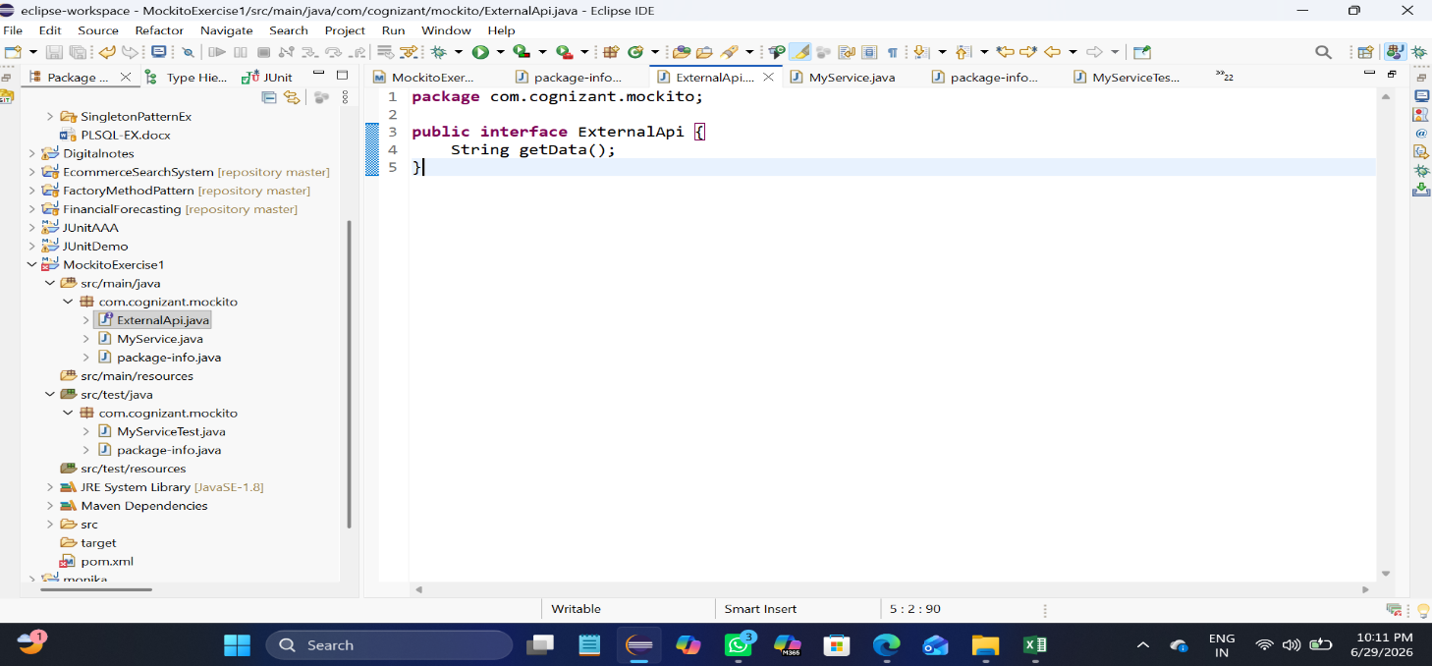
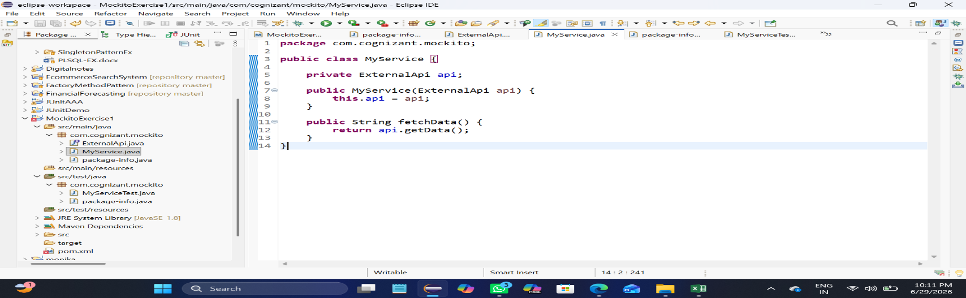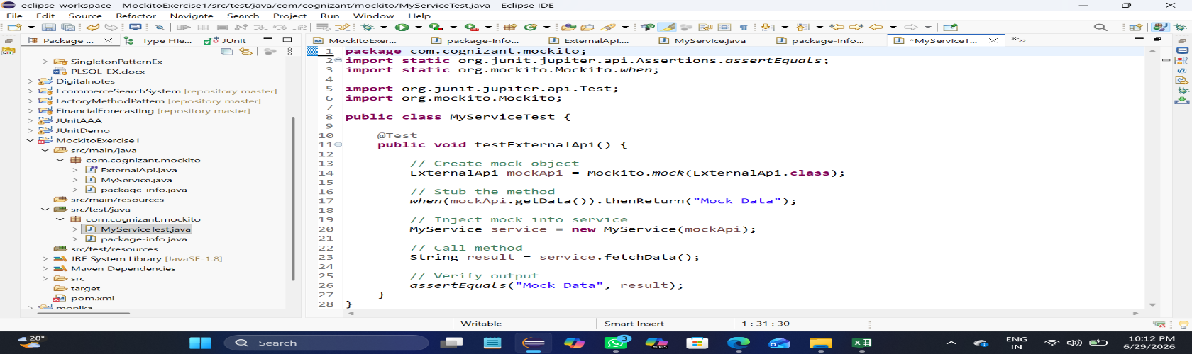

OUTPUT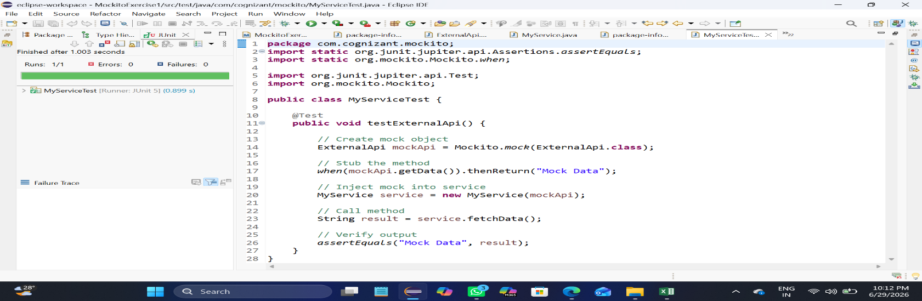

Exercise 2: Verifying Interactions:
package com.cognizant.mockito;

import static org.mockito.Mockito.verify;

import org.junit.jupiter.api.Test;
import org.mockito.Mockito;

public class VerifyInteractionTest {

@Test
public void testVerifyInteraction() {

ExternalApi mockApi = Mockito.mock(ExternalApi.class);
MyService service = new MyService(mockApi);
service.fetchData();
verify(mockApi).getData();
}
}
